**EXCEPTION HANDLING ASSIGNMENT**

1.Write an application that accepts two numbers, divides the first number with the second number and display the result.

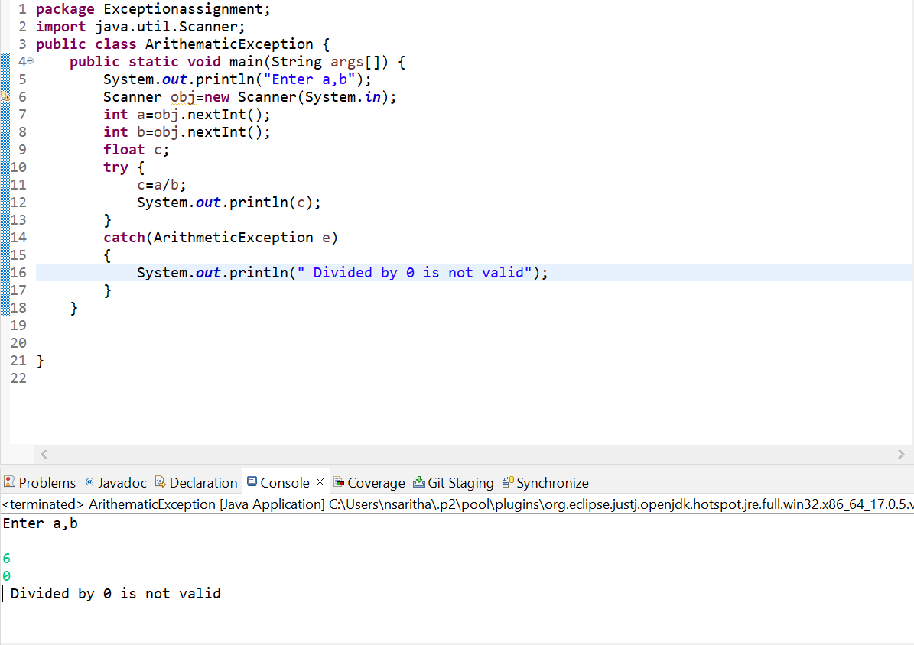

2.Carrying forward with the above problem, handle Arithmetic Exception by raising UnsupportedOperationException as a solution.

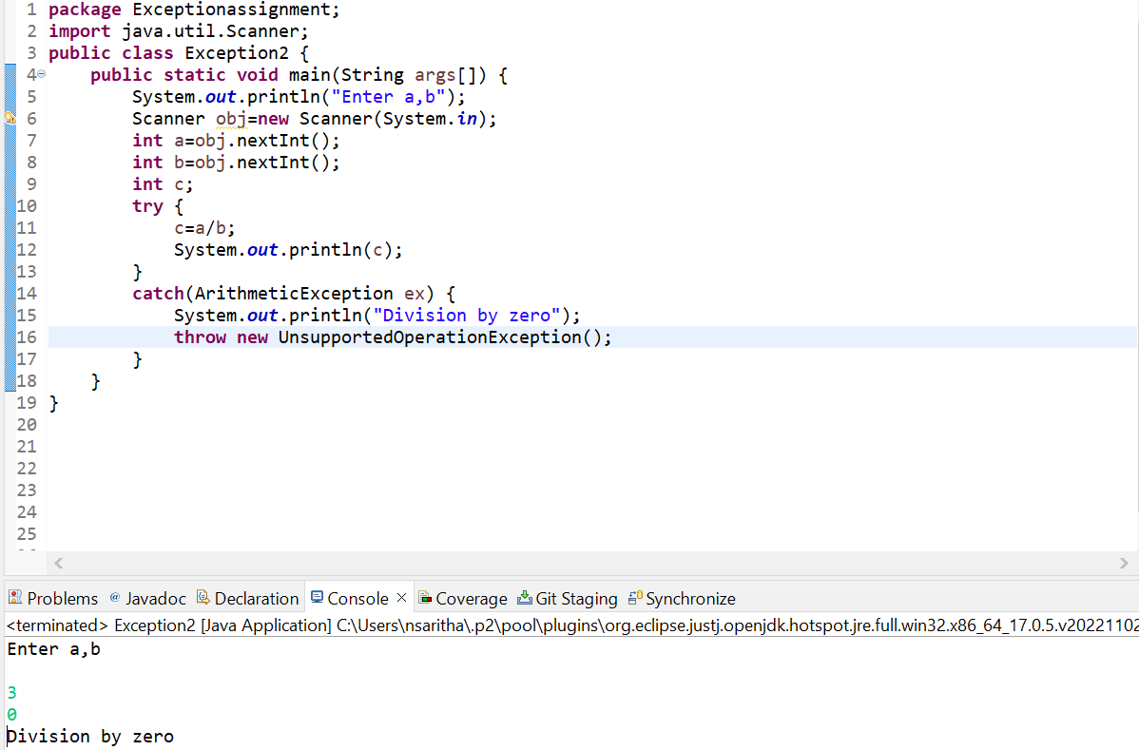

3.Write an application to perform withdraw functionality on a SavingAccount object. Point to note:

A. Raise InsufficientBalanceException. If you are trying to withdraw more than balance or when you balance is Zero.

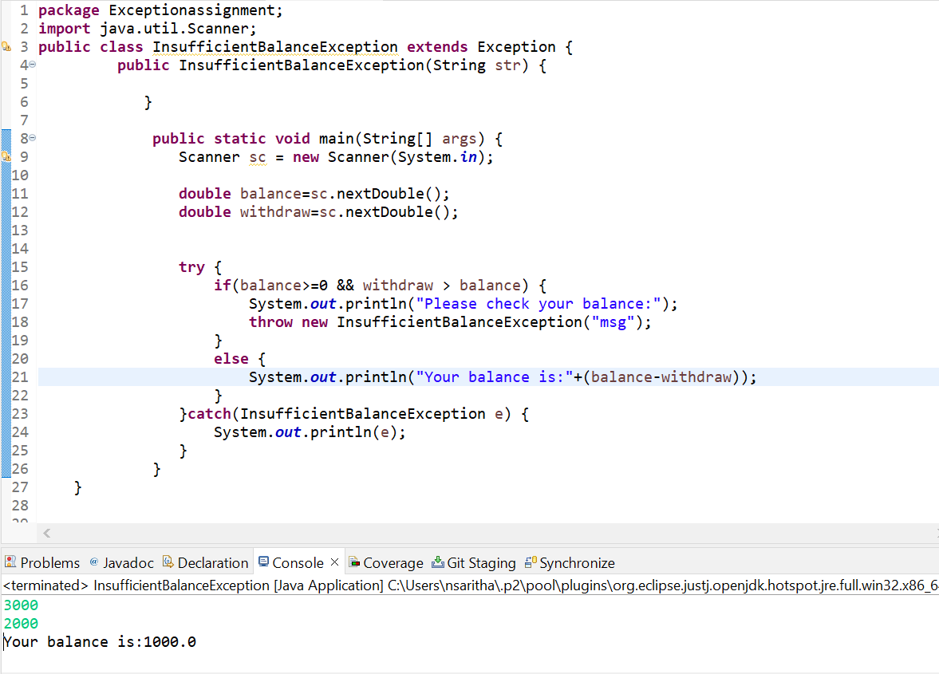

B. Raise IllegalBankTransactionException. If you are trying to withdraw a negative value from your balance.

